OPERATING & MAINTENANCE MANUAL
VME – SwingLift Cranes – KJ Range
PH_VME_OM_005 Rev 7

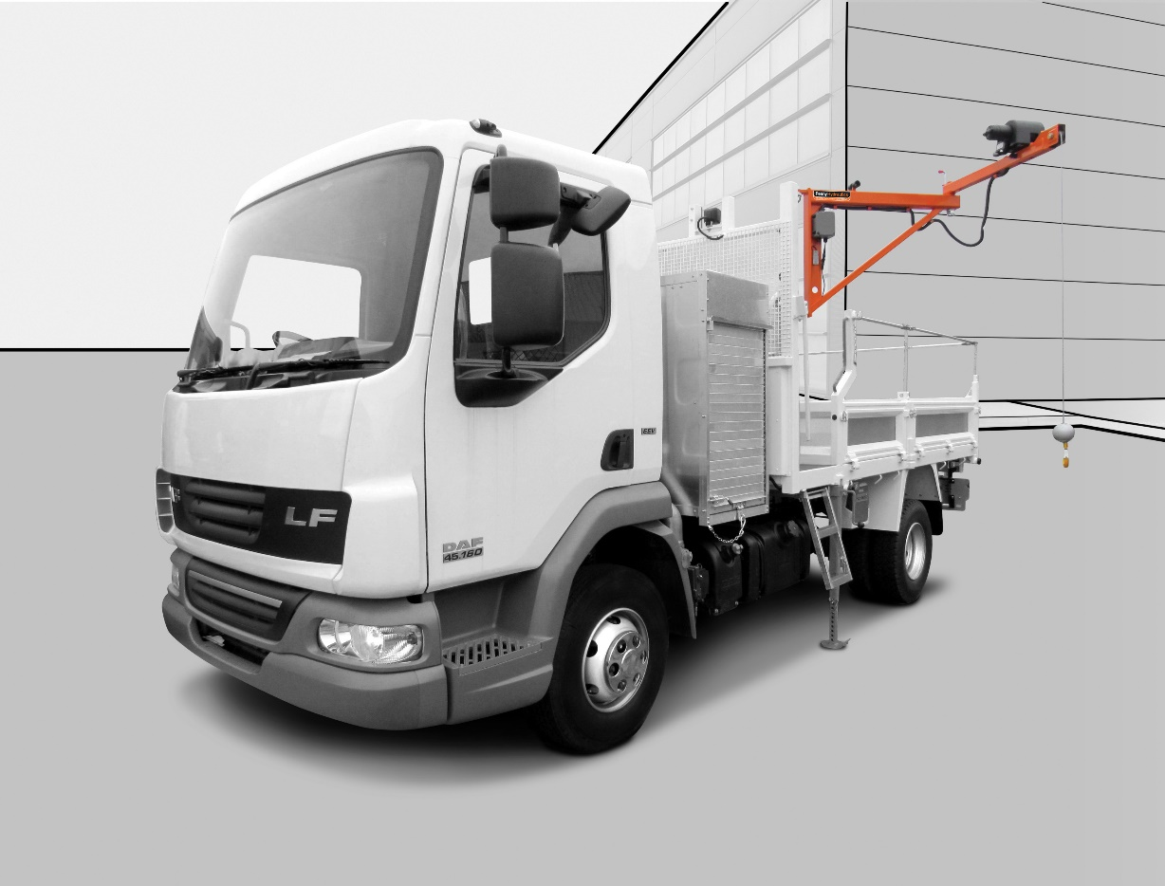

Contents

Safety Information 4
Introduction 7
Range Overview 8
SwingLift KJ250/1 8
Dimensional Drawing 8
SwingLift KJ250/1.5 9
Dimensional Drawing 9
SwingLift KJ250/2 10
Dimensional Drawing 10
SwingLift KJ250/2 RPT 11
Dimensional Drawing 11
Method of Operation 12
Prior to Operation 12
Operation 12
Transportation 13
Maintenance 14
Planned Maintenance Schedule 15
Interval 15
Daily / Before Use 15
Weekly 15
3 Monthly 15
6 Monthly 15
12 Monthly 15
Load Test Procedure 16
Method 16
Overload Test 16
Fault Finding 17
Thorough Examination 18
BS7121 Part 2 18
Lorry Loader Servicing 19
Technical Data 20
Power Supply 20
Electrical Specification 20
Typical Weights 20
Safe Working Load 20
Noise Levels 20
COSHH - Terminal Disposal 20
Typical Wiring Layout 21
Spare Parts List 22
KJ250/1 – Exploded View 22
KJ250/1 – Parts List 23
KJ250/1.5 – Exploded View 26
KJ250/1.5 – Parts List 27
28
KJ250/2 – Exploded View 30
KJ250/2 – Parts List 31
KJ250/2 RPT – Exploded View 32
KJ250/2 RPT – Parts List 33
EC Declaration of Conformity 36
Training Register 37
Work Record 38
Penny Hydraulics Limited Warranty Policy 39
UK Mainland 39
Other Locations 39

Safety Information
For optimum safety and to keep your Penny Hydraulics SwingLift in good working order, follow these simple Dos and Don’ts.


Do not exceed the Maximum Working Load
Your Penny Hydraulics lifting equipment is clearly marked with the MWL (Maximum Working Load).


Do not drag or tow
To avoid damage to the SwingLift and mounting points, it must be used only for lifting.


Do not expose the red section of rope
This section is marked to alert the user that they are approaching the full extent of the rope and should not proceed further.


Do not wrap the rope around the load
This will cause excessive chafing and splintering of the rope. Appropriate lifting accessories should be used instead.


Rope must not spool from top of winch
If your wire rope is spooling from the top of your winch, the rope is wound incorrectly on the drum. The SwingLift must not be used until this is rectified.


Do not leave a load suspended
Never leave a load suspended or unattended.


Always use the rope hook to stow the crane
The rope hook is one of several methods used to secure the crane for transit.


If supplied, always use the stabiliser leg
Not every Penny Hydraulics SwingLift is supplied with a support leg but when this is supplied, it must be used.


Always stow the crane before driving
To avoid damage to the SwingLift, vehicle and surroundings, the crane must be stowed correctly before driving.

- In the interest of safety, all personnel involved in the operation of the crane must read and understand this manual. If they do not then they must not operate the equipment.
- Do not use the KJ250 if it is not supported by valid documentation recording a Thorough Examination being carried out by a Competent Person within the last 12 months.
- The KJ250 must not be used for man riding.
- The KJ250 should be inspected every six months and serviced annually by a competent person. See “Maintenance” in this manual for full Statutory responsibilities.
- The KJ250 must not be overloaded. Refer to the safe working load signs attached to the equipment.
- The KJ250 must only be operated by trained and competent personnel. Training can be arranged by Penny Hydraulics and a training register is included at the back of this manual.
- Use only correct and certified lifting attachments. Lifting attachments must be formally certified by Thorough Examination every 6 months.
- Use only genuine parts and accessories.
- During operation of the KJ250, access to the area should be restricted to those personnel essential to the operation only.
- Do not leave any load suspended between lifting / lowering operations.
- All safety notices must be adhered to at all times.
- Keep the KJ250 properly maintained by a competent person. See the “Maintenance” section in this manual.
- Do not adjust or interfere with any factory settings.
- Isolate, immobilize and lock-off the equipment before commencing any maintenance routine.
- Ensure any site-specific barriers, guards and fencing are securely in place before commencing any work.
- Do not modify or re-install this machine without seeking guidance from Penny Hydraulics Ltd.
- Do not allow any person beneath a suspended or moving load.
- Never interfere with the unit. It should run smoothly at all times, if in doubt call the HELPLINE telephone number 01246 811475.
Improper Usage
It is forbidden:
- To use the loader in different operations from those it has been designed and built for.
- For pulling loads with loader in horizontal position.
- To operate the loader for procedures different from those described in this manual, or using
- components and attachments not approved when the crane was designed.
- Non observance of the established maintenance programs.
- Non observance of safety rules.
- No Man-riding.
- To make modifications involving loader components or parameters related to the working cycle.
- To use unauthorized spare parts and components not specifically approved by the Manufacturer.
- To carry out modifications or structural changes without the approval of the Manufacturer.
- To operate the loader outside the design temperature range: -20¡ C/ +40¡ C (-4 ¡F/ + 104 ¡F).??
Improper usage or failure to observe these essential safety requirements observance will cause:
- Immediate cancellation of the Manufacturer Warranty
- Cancellation of Manufacturer liability.
Safety Devices:
All the safety devices required by the CE Regulations are installed on Penny Hydraulics SwingLift Cranes (loaders). These devices are listed and described in the following pages.

Introduction
Pillar
(vehicle specific)
Corner Bracket
Top Bracket
(vehicle specific)
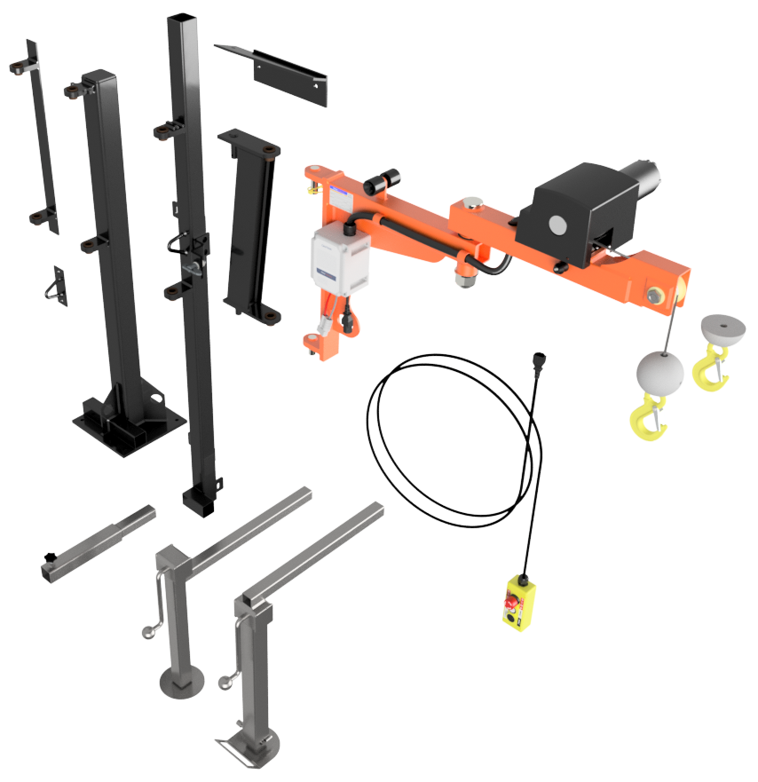
Support Leg Extension
Manual Support Leg
Drop Down Support Leg
½ Bob Weight
(to increase lift)
Rope Hook
(Bulkhead Mount)
Combi Pillar
(van/pickup Type)
Winch Assembly
Remote Control
(3 button handset)
Winch Rope Assembly
Antiluce Fastener
Crane Section Only
Cranked Hinge

Thank you for purchasing a Penny Hydraulics SwingLift Knuckle Joint crane.
The SwingLift KJ250 is a vehicle mounted crane designed and manufactured at our factory in Chesterfield, UK to safely lift and position loads of up to 250kg.
The crane is operated remotely from a handheld pendant control with all functions being protected by inbuilt overload features, powered by the vehicle battery.
These operating instructions tell you what you need to know about its operation along with guidance on safety and general care. Please study them carefully.
Due to our company’s policy of continuous improvement, the following descriptions and illustrations used in this manual and parts book are without prejudice. We reserve the right to make alterations in order to increase the performance of our product, or for any other reason. We are not obliged to alter these instructions accordingly.

Range Overview

The KJ range of cranes consists of four basic models:

SwingLift KJ250/1
250KG maximum capacity knuckle joint crane with a 1m boom allowing lifts within a 2m arc. Most commonly van or headboard mounted.

Dimensional Drawing

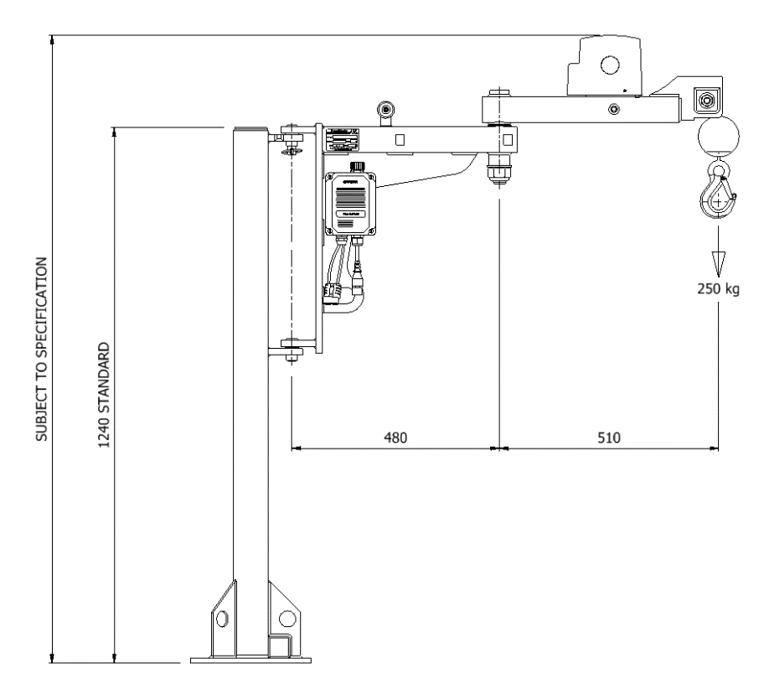

SwingLift KJ250/1.5
250KG maximum capacity knuckle joint crane with a 1.5m boom allowing lifts within a 3m arc. Most commonly van or headboard mounted.

Dimensional Drawing
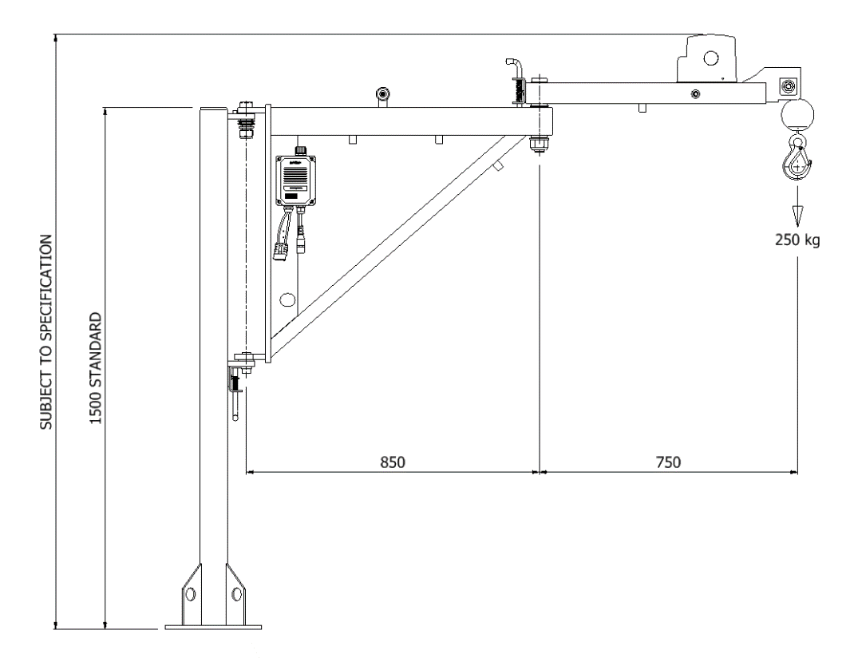

SwingLift KJ250/2
250KG maximum capacity knuckle joint crane with a 2m boom allowing lifts within a 4m arc. Pick-up, combi-pillar or headboard mounted.

Dimensional Drawing

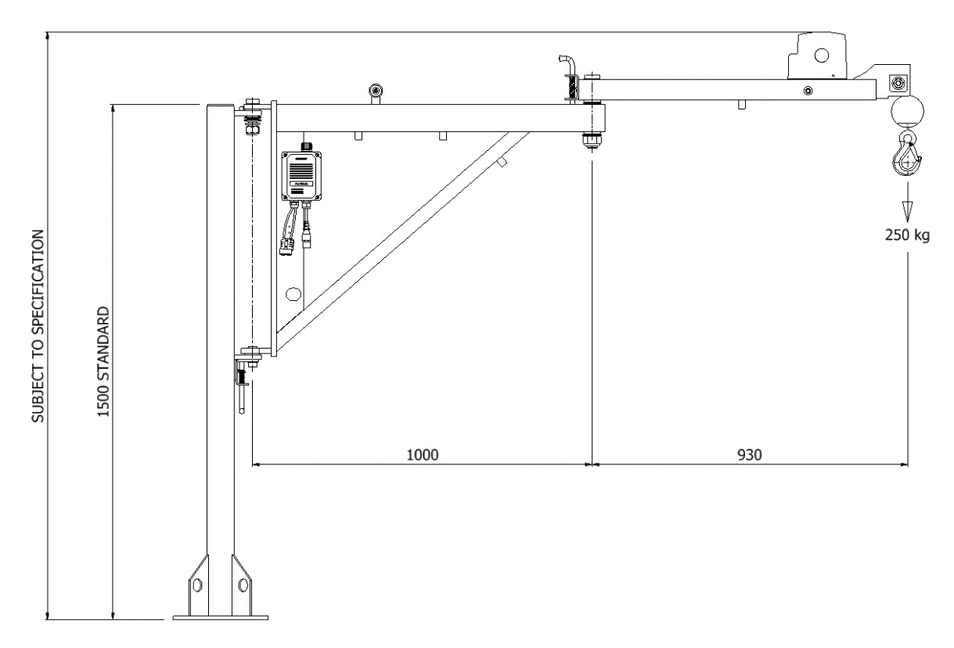

SwingLift KJ250/2 RPT
250KG maximum capacity knuckle joint crane with a 2m boom allowing lifts within a 4m arc and 350° slew.

Dimensional Drawing

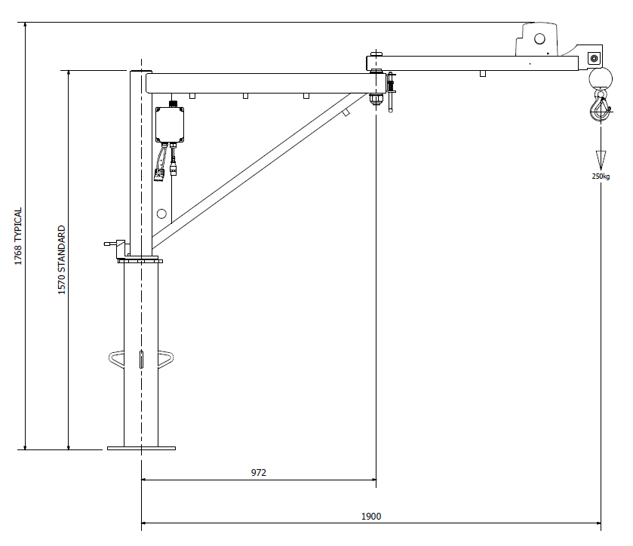

Method of Operation

Prior to Operation

- Read the Operating and Maintenance manual and ensure all persons involved in the lift are trained and competent to do so.
- Check and ensure that the necessary documentation for the KJ250 and Lifting attachments is valid and up to date. Ensure that the Report of Thorough Examination does not exceed 12 months for the crane and 6 months for the associated lifting accessories.
- Ensure you have a risk assessment for the lift to be undertaken.
- Employ any PPE equipment required or stipulated by your employer or risk assessment.
- Ensure the crane installation is inspected prior to use for defects (see Planned Maintenance Schedule).
- Ensure the vehicle is on firm and level ground with the handbrake applied and wheel chocks deployed where necessary.
- Before operating check for potential hazards such as: overhead electric wires, nearby structures, public roads or paths, railways or rivers. Also pay attention to any underground services; eg gas, electric, drainage etc. Employ barriers or safety guarding required and identified by the risk assessment.
- Extend the support legs (if supplied) and adjust to ground level using a suitable spreader pad if necessary.
- Check the power connector from the vehicle is firmly in place.
- Plug in the pendant control to the control box on the side of the boom support.
- Using the pendant control button, lower the rope and release it from the rope retaining eye.
- Release the boom retaining latch (Antiluce fastener) and manually position the rope over the load.
- The crane is now ready for use.

Operation

- The pendant control functions are clearly marked on the hold to run buttons and can now be used as required.
- Ensure the pendant e-stop is disengaged.
- Check that the load to be lifted is within the capacity of the crane.
- Position the load hook directly above the load. The crane should be used for vertical lifting only. No dragging of the load. No man riding.
- Lower the lifting hook and attach using suitably certified lifting attachments only.
- Carefully lift the load and manoeuvre to the required position. Do not steer the load by pulling or pushing on the wire rope.
- Keep clear of the suspended load as far as practically possible and do not try to physically restrain it if the balance suddenly changes. Never stand beneath the suspended or moving load.
- Do not leave the suspended or attached load unattended.
- Do not to drive the vehicle with a suspended load or drive with the support legs in the down position.
- On completion of the operation, ensure the KJ250 is folded into the transport position with the rope attached to the retaining eye and all the locking devices firmly secured.
- Always level the loader using the support legs (where supplied). The Maximum operating angle is 5°..
- Detach the pendant control and store securely.

Transportation

Ensure all latches and methods of stowage shown below (Where applicable) are fully secured and the winch rope is tensioned before moving the vehicle.

The KJ250 is available with different boom lengths and can be pillar mounted in a van, pillar mounted in a pick up or gantry mounted on the headboard.

Each crane will have at least two methods of stowage. The crane must be stowed by at least two methods of stowage when the vehicle is in transit.

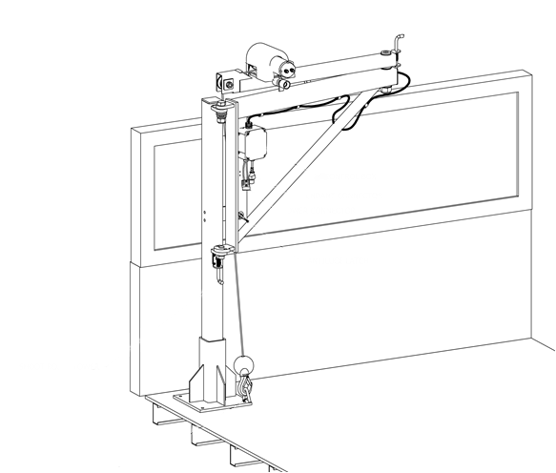
Antiluce Fastener
Rubber holder
Lower shoot bolt
Rope hook

Maintenance

Your SwingLift KJ250 series vehicle mounted crane is subject to the Lifting Operations and Lifting Equipment Regulations 1998 (LOLER) which is a statutory requirement to record on a formal document, the safe working condition of the crane, attachments and mounting structure.

Penny Hydraulics Ltd Service Team offers a service package to meet customer requirements and conform to LOLER certification. Please see Service Contract form enclosed.

The following Planned Maintenance Schedule is designed to monitor the safe working order of the KJ250 and includes a Thorough Examination by a Competent Person required by LOLER.

LOLER also requires that a Thorough Examination is carried out following any exceptional circumstance that may affect the safety of the equipment. Such as structured change or re-fitting the crane to a new vehicle.

Any defects found whilst carrying out the Planned Maintenance Schedule must be reported and recorded and the equipment taken out of operation until action by a Competent Person is undertaken.

The Planned Maintenance Schedule may require the use of parts and consumables, call 01246 811 475 for further assistance.

Planned Maintenance Schedule

Before any work is undertaken, ensure the site supervisor is informed and that all safety precautions are observed and adhered to.
Pay attention to site specific safety and PPE requirements.
Unless dynamic checks, tests or setting up procedures are being carried out, always isolate the machine from the power supply.
Where dynamic checks are being performed, it is recommended that an assistant is designated to be on call if required.
Ensure a clean working area and sufficient cleaning materials.
Ensure the work area is cordoned off, paying particular attention to the sweep areas required for dynamic testing.
On receipt of a new machine and before it is put into service, check that there is no transit damage or evidence of mishandling.

Interval | Maintenance Task
Daily / Before Use | Check the hoist rope is coming off the bottom of the winch drum.
Daily / Before Use | Check visually for signs of external damage such as cracks or flaked paint.
Daily / Before Use | Check all guards are securely in place.
Daily / Before Use | Check for loose or missing nuts, bolts and fasteners.
Daily / Before Use | Check the hoist rope for kinks, broken strands and corrosion.
Daily / Before Use | Check the lifting hook and connection to the rope.
Daily / Before Use | Check for damage to electrical cables and connectors
Weekly | Check all as for Daily.
Weekly | Thoroughly clean the support structure and check the security of the interface with the vehicle.
3 Monthly | Check all as for Daily, Weekly.
3 Monthly | Remove the rope assembly from the winch and check the full length for kinks, broken strands and corrosion. Replace if necessary.
3 Monthly | In severe operating conditions, remove the pin and rope pulley and check for excessive wear. Replace if necessary.
3 Monthly | Re fit the pulley and rope assembly ensuring smooth lapping on the winch drum.
6 Monthly | Check all as for Daily, Weekly, Monthly and 3 Monthly.
6 Monthly | Thoroughly examine the main structures and sub frames for soundness and signs of deflection.
6 Monthly | Thoroughly inspect all welds.
6 Monthly | Thoroughly check the security of all fixings on the main body and sub frames.
6 Monthly | Thoroughly examine all pivot points for excessive play. Remove the pivot pins and thoroughly inspect the condition of the pins and bushes and replace where necessary.
6 Monthly | Thoroughly examine all electrical components, cables and connectors.
12 Monthly | Check all as for Daily, Weekly, 3 Monthly and 6 Monthly.
12 Monthly | Carry out a full load test as set out in the Load Test Procedure.
12 Monthly | Carry out a statutory thorough examination as required by LOLER.

Load Test Procedure

A load test must be carried out periodically to assess the integrity of the KJ250 and its supporting structures.
Any defects or signs of potential failure must be rectified before the machine is allowed back into service.

Warning: This procedure must only be carried out by suitably qualified, experienced and trained personnel.

Method

- Prepare the vehicle for operation in a safe working area, with the support leg firmly set and cordon off the area with appropriate barriers and work in progress signs.
- Prepare the maximum prescribed test weights as determined by the KJ250 model number.
- Clear the site, admit power, connect the pendant control and rotate the KJ250 in line with the axis of the chassis and the boom outboard.
- Without load, manoeuvre the crane through all extents to ensure correct operation.
- Lower the rope and attach the hook to the test weight prescribed.
- Raise the load clear of the ground.
- Check for signs of excessive flexing, structural deformation, paint flaking and excessive play in the joints.
- Rotate the KJ250 through its maximum swing and repeat the checks.
- Return the weight to its starting position and detach.

On completion of the tests, restore the vehicle to its normal driving position, restore the working area and complete the necessary documentation.

Overload Test

An overload test is carried out on all new KJ250s at the factory and forms part of the test certificate requirements.
If the KJ250 is fitted to the vehicle by Penny Hydraulics Ltd or one of its authorized dealers, the system including the sub structure and vehicle interface will be Overload Tested as part of the test procedure.
An Overload Test must be carried out if:

- The KJ250 is fitted to a new or modified structure.
- Any Modifications have been carried out to the KJ250 or support structure.
- Following any incident which may have caused damage to the KJ250 or its supporting structure.

Warning:
To carry out an Overload Test, elements of the system protection features must be overridden and therefore must only be carried out by suitably qualified, experienced and trained personnel.
In severe or extreme conditions, it is recommended that an Overload Test is incorporated into the Annual Load Test of KJ250 and its supporting structure
Please contact Penny Hydraulics Ltd for further information.

Fault Finding
If in doubt, contact our Service Department on: 01246 811 475
Fault | Cause | Remedy
No response when operating Raise / Lower buttons | No power from battery | Check supply fuse and replace if necessary. Check all cable connections are clean and sound
No response when operating Raise / Lower buttons | Faulty earth connection | Check, clean and secure all earth points
No response when operating Raise / Lower buttons | Faulty or discharged vehicle battery | Re charge or replace battery
Crane will not lift but will lower | Crane overloaded | Lower off and remove excessive load
Crane will not lift but will lower | Rope bunched on pulley or winch | Ensure that rope is free to travel
Crane will not swivel freely | Bushes / pivot bearings seized | Loosen, clean and reset
Clicking noise from gearbox | Solenoid faulty | Check all cable connections. Replace Solenoid
Crane only operates in one direction | Rope coming off the top of the drum | The rope needs to be re-fitted correctly
 | Faulty remote control | Replace remote control
 | Faulty solenoid | Replace Solenoid
 | Faulty brake | Replace winch motor
Winch excessively noisy | Worn gearbox | Replace winch
Winch will not operate in either direction | Broken gearbox | Replace winch
 | Faulty motor | Replace motor
 | Faulty solenoid | Replace solenoid

Thorough Examination

The Lifting Operations and Lifting Equipment Regulations (LOLER) replaced the legal requirement for the four-yearly Overload Test with the annual Thorough Examination and Inspection, and made it the responsibility of the Competent Person to determine if and when an Overload Test should be carried out, on the grounds that "the design of certain lifting equipment is such that damage may be caused by conventional Overload Tests". Loader cranes do not fall into this category, as witnessed by the fact that BS7121 Part 2 has an entire section devoted to the testing of loader cranes. Load Testing is a requirement of ALLMI and BS7121 Parts 2 and 4.

Inspection of the lorry loader by a competent person to determine if it is safe for continued use until the next thorough examination is due. Thorough Examinations should be conducted at least every 12 months. A thorough examination will also be required:
- If the lorry loader is involved in an accident or dangerous occurrence.
- After a significant change in conditions of use.
- After long periods out of use.
- At shorter intervals as determined by the Competent Person.
Please note that in addition to the above, lifting equipment for lifting persons or an accessory for lifting, must be thoroughly examined at least every six months.

BS7121 Part 2

Occasion | Minimum test and thorough examination
Before being first taken into service | Full test including 25% overload
Annually after being first put into service | Proof load test of rated capacity +10% at full radius and through the full slewing arc, and a Thorough Examination
4 years after first being put into service | Full test including 25% overload
8 years after first being put into service | Non-destructive test of the structure
After each structural repair or component change | Full test including 25% overload
When chassis is changed | Full test including 25% overload
Is removed and refitted | Full test including 25% overload

Lorry Loader Servicing

Penny Hydraulics has been manufacturing lifting equipment for over 40 years. All of our products are supported by a fleet of dedicated service vans fully stocked with original equipment spares and manned by trained engineers.
Current legislation requires that each item of lifting equipment must be thoroughly examined at least once in every period of twelve months by a competent person. Additionally, the lifting equipment must be inspected at suitable intervals between thorough examinations. Our service contract will ensure continued safe, reliable use of the equipment and full compliance with current legislation.
The operator is required to carry out regular inspections and report any faults found.
The standard contract provides for an annual service and an interim six-monthly inspection or for total piece of mind we offer a Fully Comprehensive option. In all cases a test certificate will be issued with a copy being left on site and a further copy sent together with our invoice. We will also keep a copy for our records that can be forwarded to enforcing authorities on your behalf as necessary.
Our database of all equipment ensures that statutory inspections are kept up to date and can help customers with many items of equipment to predict forthcoming servicing budgets.
A Help Line telephone number is provided with each service contract for the operators to seek assistance directly from our Service Department. There is no call out or labour charge for help required in-between scheduled visits and any parts used will be charged on the next invoice.
Should this be of interest then in the first instance please contact the Service Department on 01246 810403.

Technical Data

Power Supply
Standard SwingLift KJ250s require 12/24V DC electrical supply. This should be terminated in a 50A SB plug. Any circuit breakers employed in the system must be of a type that can cope with the surge of the electric motor.

Electrical Specification
12 volts DC 40A
24 volt DC 70A
240 volt – contact Penny Hydraulics Ltd.

Typical Weights
SwingLift KJ250 32.5kg – 100kg subject to specification including winch unit.

Safe Working Load
Each SwingLift KJ250 is marked individually with its Maximum Working Load.

Noise Levels
A survey sheet giving full details is available on request. Briefly, the results are as follows: -

Winch running 65dB(A)

These levels are well below those at which hearing can be damaged and below levels at which action is required under the noise at work regulations.

COSHH - Terminal Disposal
Penny Hydraulics will remove and dispose of the entire crane in an environmentally sound manner when required.

Typical Wiring Layout

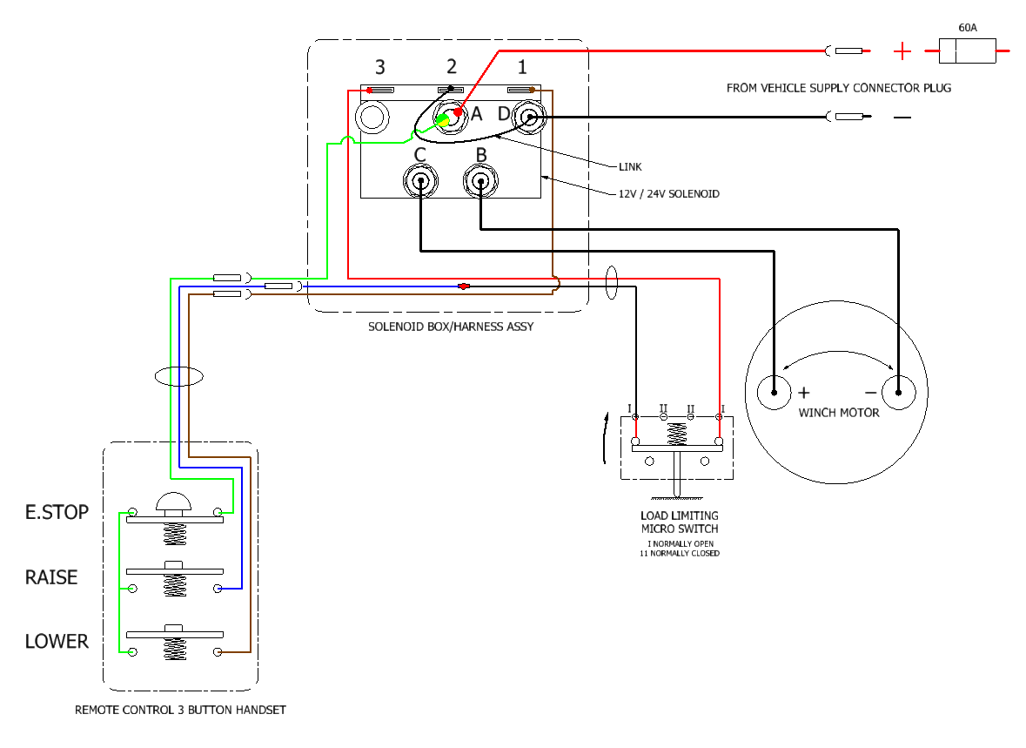

Spare Parts List

KJ250/1 – Exploded View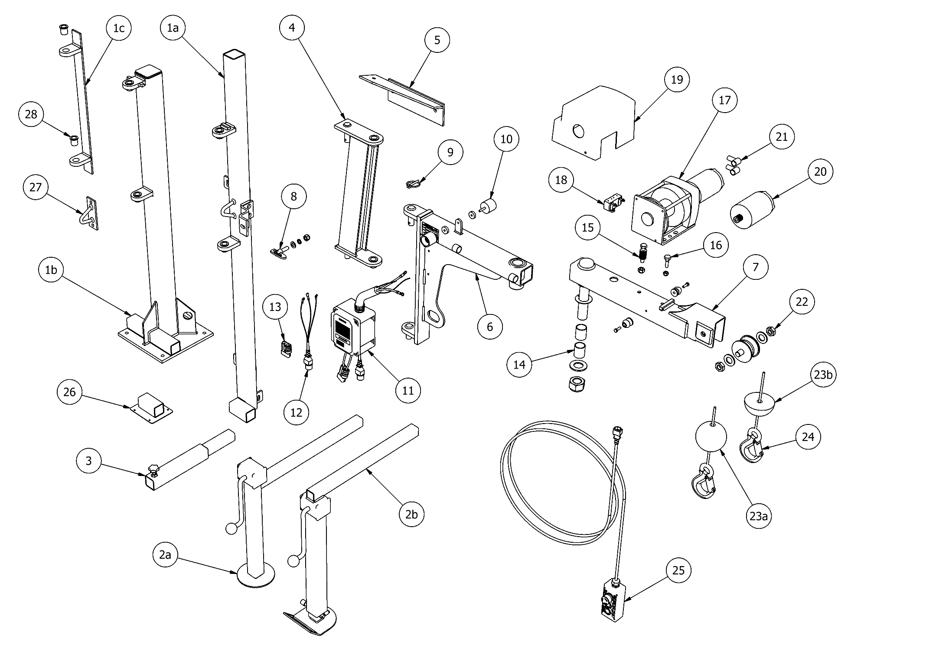

KJ250/1 – Parts List

ITEM |  | PART NUMBER | DESCRIPTION | QTY
1 | a | Subject to Specification | Van Pillar - Assembly | 1
 | b | 541-000124 | Combi Pillar - Assembly | 1
 | c | 011-000441 | Corner Bracket - Assembly | 1
2 | a | 190-000006 | Support Leg (2 Tier) - Assembly | 1
 | b | 190-000015 | Support Leg (3 Tier) - Assembly | 1
3 |  | 503-000078 | Leg Extension - Assembly | 1
4 |  | 158-000029 | Cranked Hinge - Assembly | 1
5 |  | Subject to Specification | Van Top Mounting Bracket - Assembly | 1
6 |  | 056-000314 | Crane Body | 1
7 |  | 056-000313 | 2nd Boom | 1
8 |  | 064-000001 | Antiluce Fastener - Assembly | 1
9 |  | 539-000043 | Lynch Pin | 1
10 |  | 173-000006 | Rubber Holder (Male & Female) - Assembly | 1
11 | a | 195-000040 | Solenoid Box & Wiring Harness - 12V | 1
 | b | 195-000041 | Solenoid Box & Wiring Harness - 24V | 1
12 |  | 547-000033 | Remote Connector & Tail | 1
13 |  | 108-000001 | Anderson Power Connector - 50A | 1
14 |  | 035-000056 | Joint Bearing - Assembly | 1
15 |  | 713-200005 | Disc Spring - Assembly | 1
16 |  | 200-000009 | Shoulder Bolt - Assembly | 1
17 | a | 077-000024 | Winch Assembly - 12V - Left Hand (LH) | 1
 | b | 077-000023 | Winch Assembly - 12V - Right Hand (RH) | 1
 | c | 077-000026 | Winch Assembly - 24V - Left Hand (LH) | 1
 | d | 077-000025 | Winch Assembly - 24V - Right Hand (RH) | 1
18 |  | 692-000008 | Microswitch - Assembly | 1
19 | a | 123-000035 | Winch Cover - L/H | 1
 | b | 123-000036 | Winch Cover - R/H | 1
20 | a | 614-000005 | Winch Motor - 12V | 1
 | b | 614-000007 | Winch Motor - 24V | 1
21 |  | 042-000001 | Terminal Rubber Boot | 2
22 |  | 555-000017 | Pulley Wheel - Assembly | 1
23 | a | 022-000002 | Bob Weight - Assembly | 1
 | b | 022-000004 | Half Bob Weight - Assembly | 1
24 | a | 079-000008 | Rope 15' (4.5m) & Hook - Assembly | 1
 | b | 079-000009 | Rope 20' (6.0m) & Hook - Assembly | 1
 | c | 079-000010 | Rope 30' (9.1m) & Hook - Assembly | 1
25 |  | 560-000016 | Remote Control (3 Button Handset) | 1
26 |  | Subject to Specification | Support Leg Stowage Bracket - Assembly | 1
27 |  | 079-000050 | Rope Hook (Bulkhead Mounted) - Assembly | 1
28 |  | 035-000049 | Flanged Bush | 2

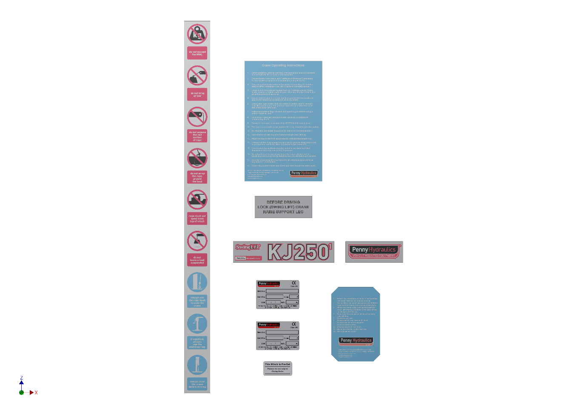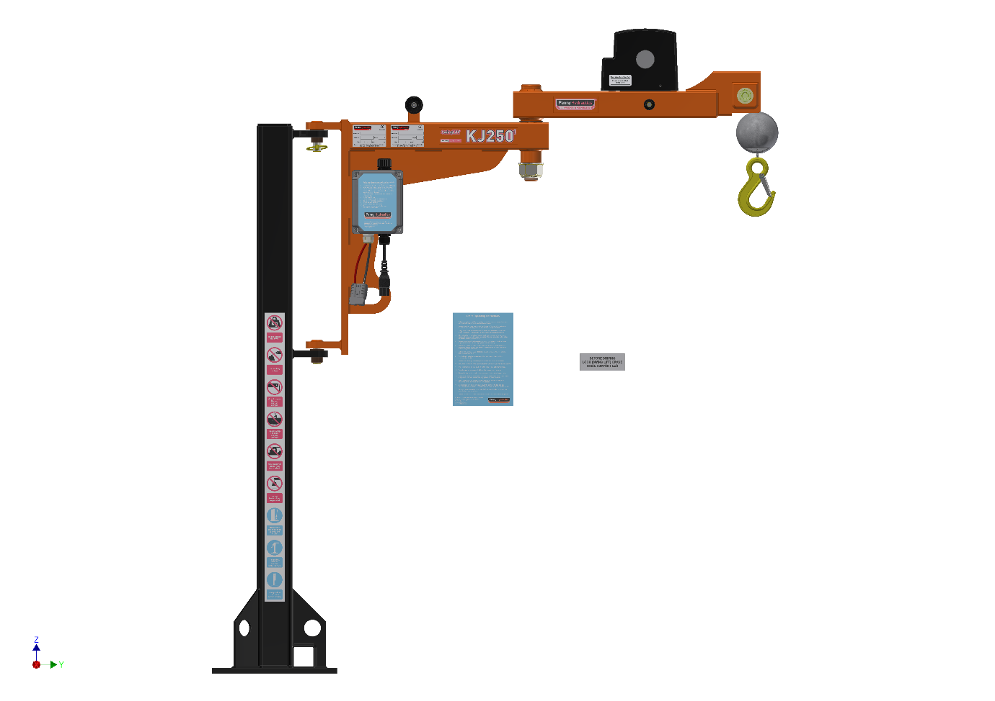

Item | Part Number | Description | Qty
1 | 500-000193 | This winch is preset sticker | 1
2 | 500-000069 | KJ250/1 Boom Label Set | 1
3 | 500-000022 | Manufacturers CE Plate | 1
4 | 500-000179 | Installers CE Plate* | 1
5 | 500-000184 | Operating Instructions | 1
6 | 500-000031 | Caution Sticker Blue | 1
7 | 500-000182 | Vertical Sticker (9 safety warning icons) | 1
8 | 500-000183 | Before driving sticker | 1

KJ250/1.5 – Exploded View
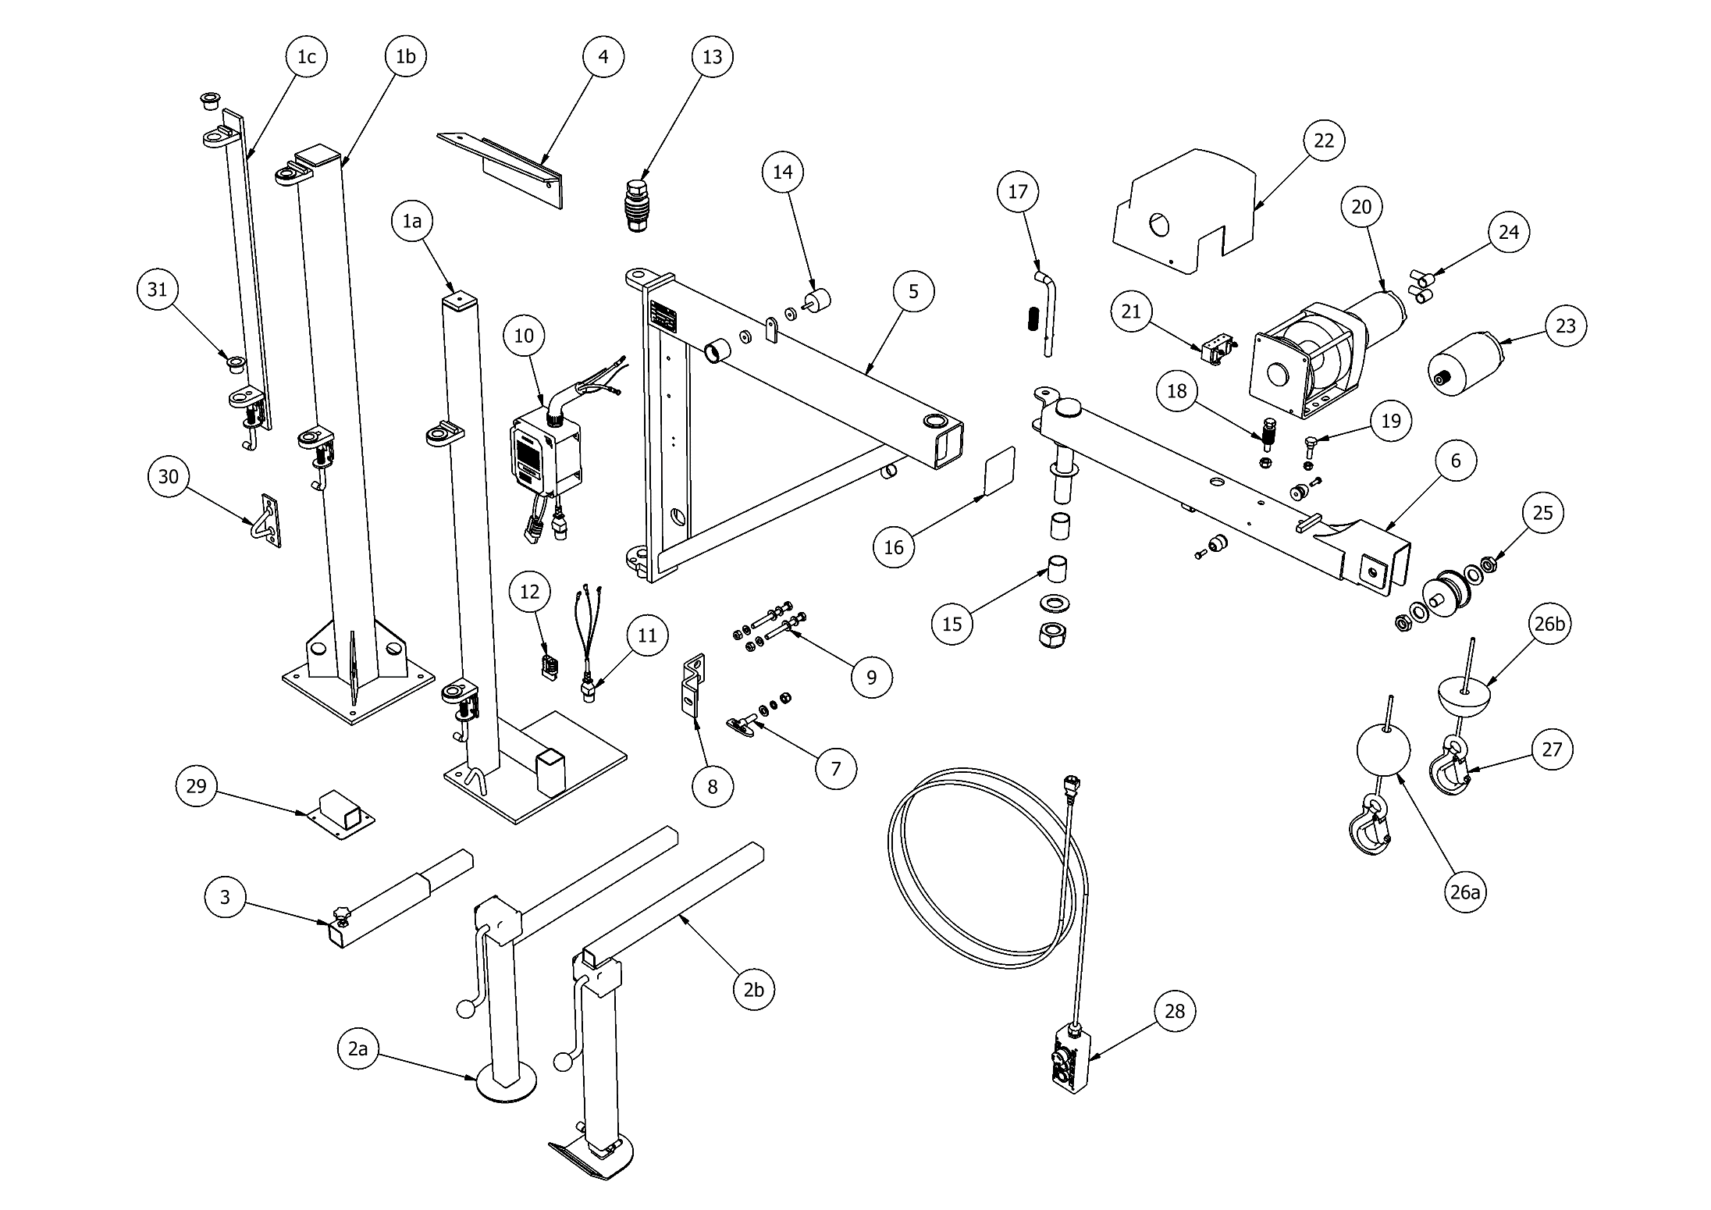

KJ250/1.5 – Parts List

ITEM |  | PART NUMBER | DESCRIPTION | QTY
1 | a | Subject to Specification | Van Pillar - Assembly | 1
 | b | 541-000012 | Combi Pillar - Assembly | 1
 | c | 011-000346 | Corner Bracket - Assembly | 1
2 | a | 190-000006 | Support Leg (2 Tier) - Assembly | 1
 | b | 190-000015 | Support Leg (3 Tier) - Assembly | 1
3 |  | 503-000078 | Leg Extension - Assembly | 1
4 |  | Subject to Specification | Top Mounting Bracket - Assembly | 1
5 |  | 056-000318 | Crane Body | 1
6 |  | 056-000319 | 2nd Boom | 1
7 |  | 064-000001 | Antiluce Fastener - Assembly | 1
8 |  | 011-000129 | Antiluce Bracket | 1
9 |  | 206-000001 | Antiluce Fitting Kit | 1
10 | a | 195-000010 | Solenoid Box & Wiring Harness - 12V | 1
 | b | 195-000011 | Solenoid Box & Wiring Harness - 24V | 1
11 |  | 547-000033 | Remote Connector & Tail | 1
12 |  | 108-000001 | Anderson Power Connector - 50A | 1
13 |  | 713-200008 | Anti-slew Tensioner - Assembly | 1
14 |  | 173-000006 | Rubber Holder (Male & Female) - Assembly | 1
15 |  | 035-000056 | Joint Bearing - Assembly | 1
16 |  | 547-000018 | End Cap | 1
17 |  | 079-000025 | Shoot Bolt - Assembly | 1
18 |  | 713-200005 | Disc Spring - Assembly | 1
19 |  | 200-000009 | Shoulder Bolt - Assembly | 1
20 | a | 077-000024 | Winch Assembly - 12V - Left Hand (LH) | 1
 | b | 077-000023 | Winch Assembly - 12V - Right Hand (RH) | 1
 | c | 077-000026 | Winch Assembly - 24V - Left Hand (LH) | 1
 | d | 077-000025 | Winch Assembly - 24V - Right Hand (RH) | 1
21 |  | 692-000008 | Microswitch - Assembly | 1
22 | a | 123-000035 | Winch Cover - L/H | 1
 | b | 123-000036 | Winch Cover - R/H | 1
23 | a | 614-000005 | Winch Motor - 12V | 1
 | b | 614-000007 | Winch Motor - 24V | 1
24 |  | 042-000001 | Terminal Rubber Boot | 2
25 |  | 555-000017 | Pulley Wheel - Assembly | 1
26 | a | 022-000002 | Bob Weight - Assembly | 1
 | b | 022-000004 | Half Bob Weight - Assembly | 1
27 | a | 079-000008 | Rope 15' (4.5m) & Hook - Assembly | 1
 | b | 079-000009 | Rope 20' (6.0m) & Hook - Assembly | 1
 | c | 079-000010 | Rope 30' (9.1m) & Hook - Assembly | 1
28 |  | 560-000016 | Remote Control (3 Button Handset) | 1
29 |  | Subject to Specification | Support Leg Stowage Bracket - Assembly | 1
30 |  | 079-000050 | Rope Hook (Bulkhead Mounted) - Assembly | 1
31 |  | 039-000002 | Flanged Bush | 2

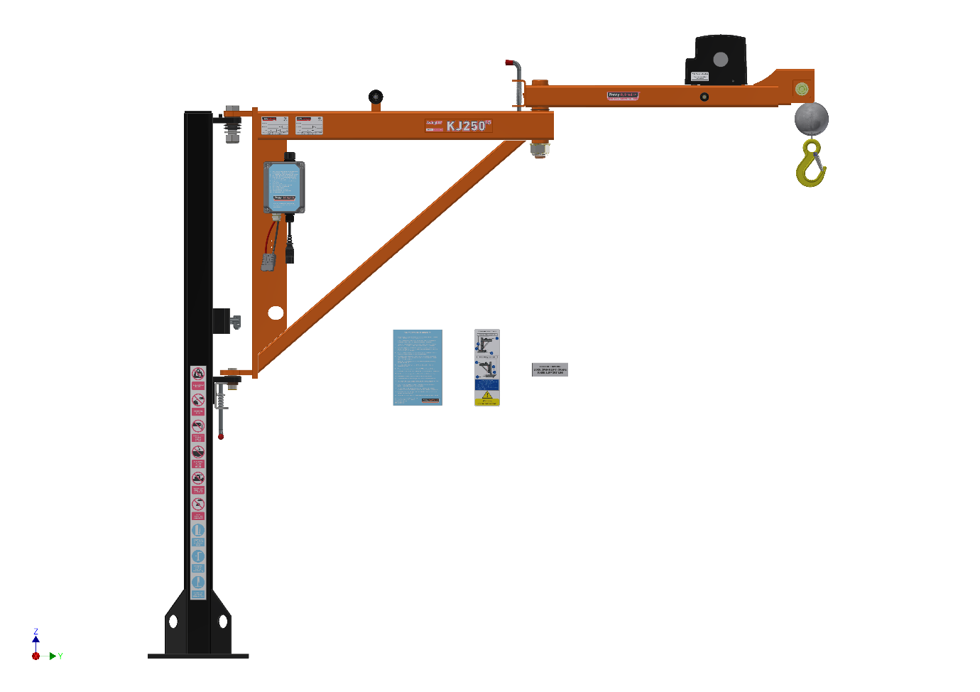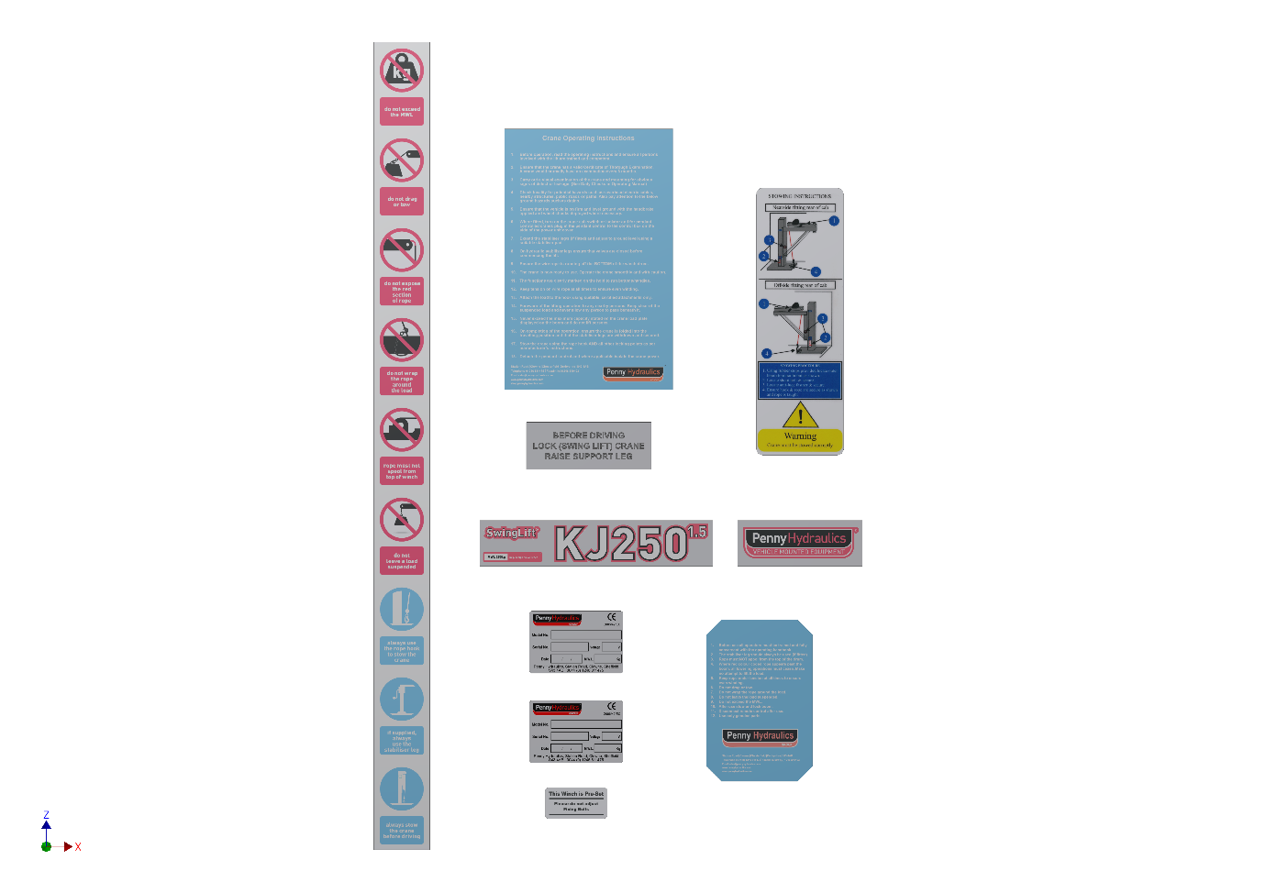

Item | Part Number | Description | Qty
1 | 500-000193 | This winch is preset sticker | 1
2 | 500-000087 | KJ250/1.5 Boom Label Set | 1
3 | 500-000022 | Manufacturers CE Plate | 1
4 | 500-000179 | Installers CE Plate* | 1
5 | 500-000184 | Operating Instructions | 1
6 | 500-000031 | Caution Sticker Blue | 1
7 | 500-000182 | Vertical Sticker (9 safety warning icons) | 1
8 | 500-000183 | Before driving sticker | 1
9 | 500-000185 | Stowing Instruction | 1

KJ250/2 – Exploded View

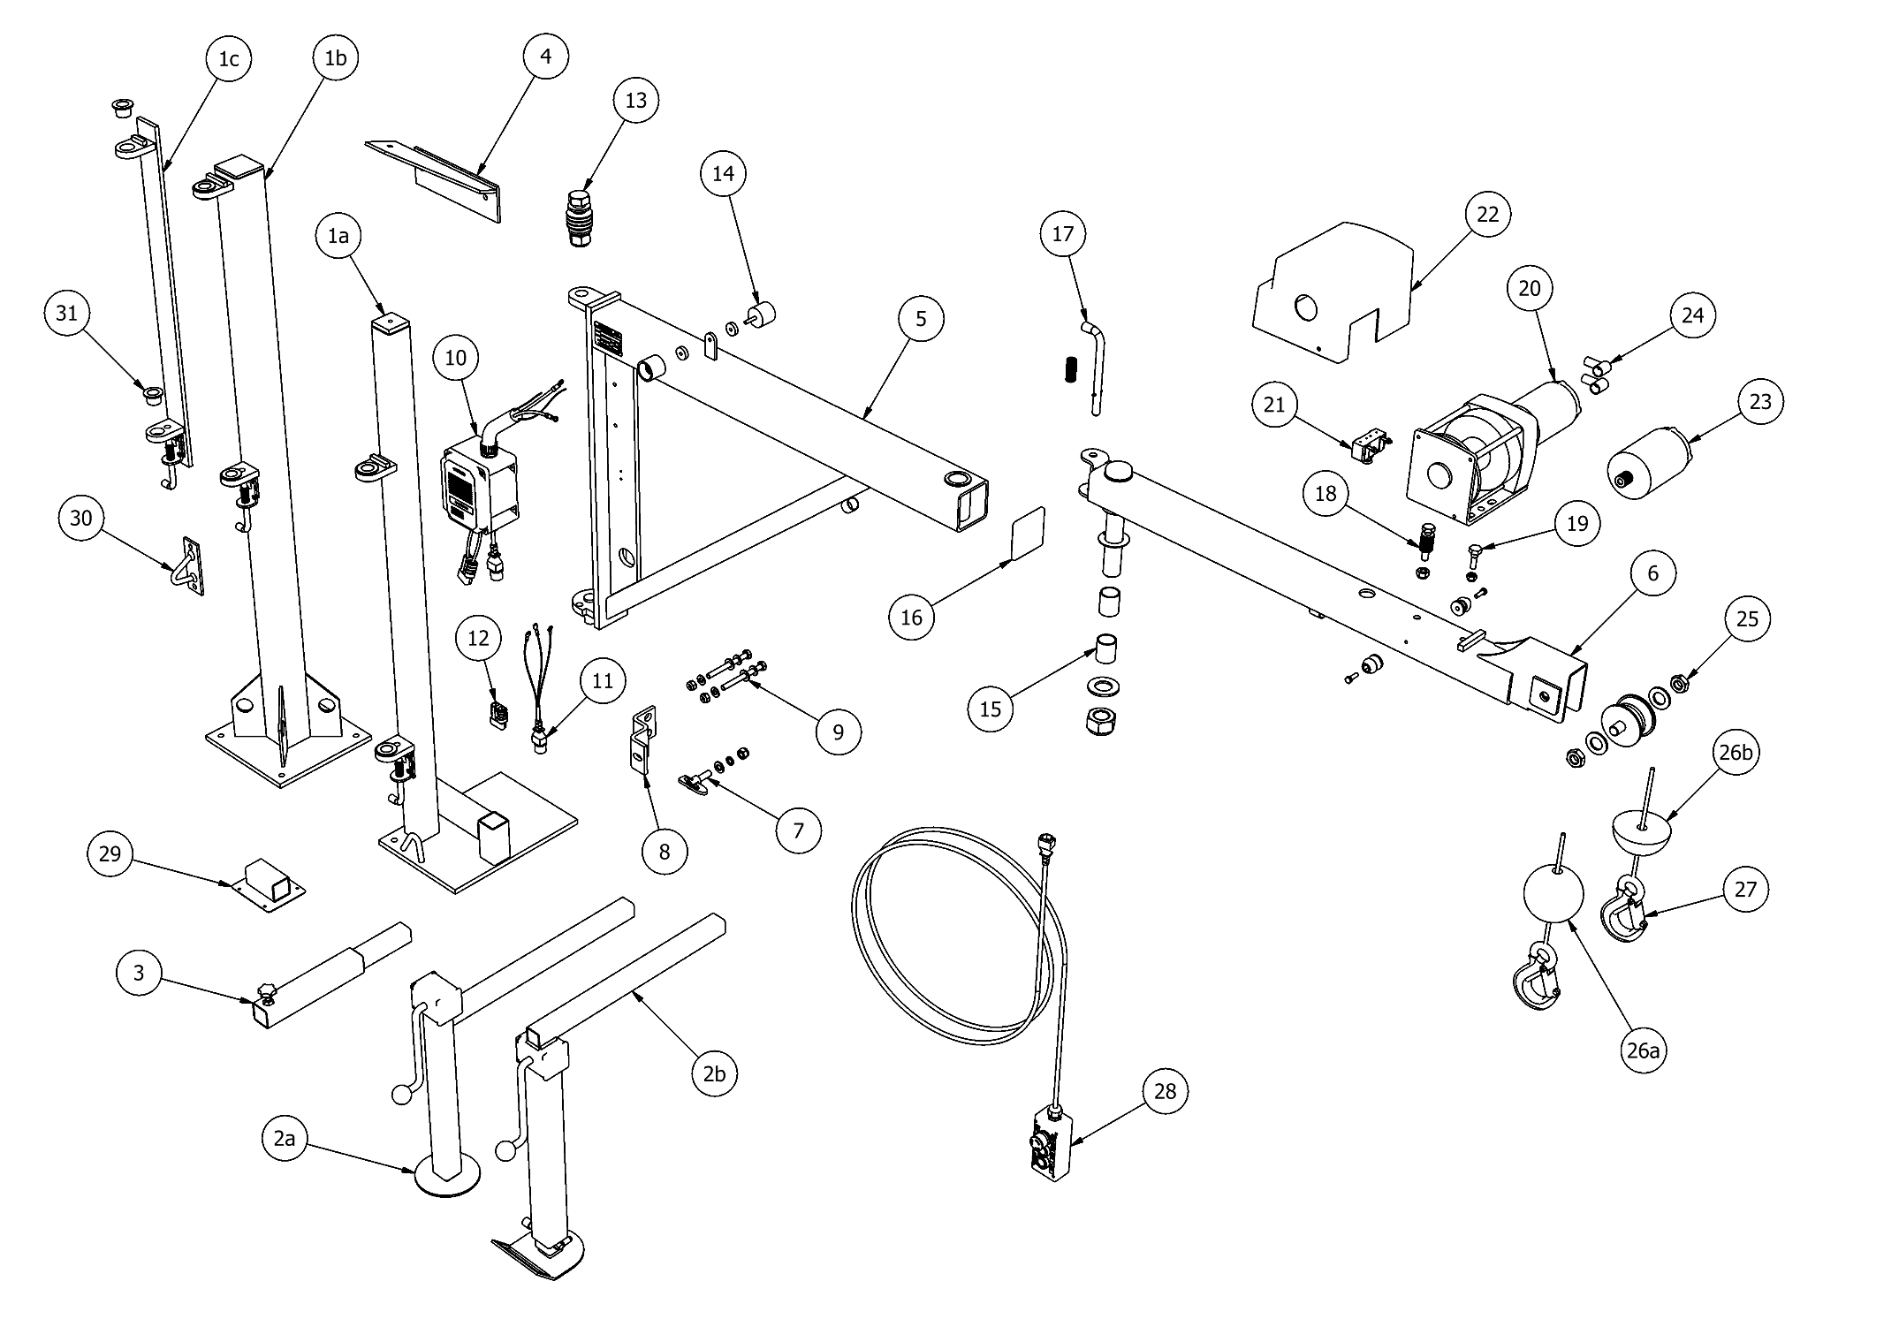

KJ250/2 – Parts List

ITEM |  | PART NUMBER | DESCRIPTION | QTY
1 | a | Subject to Specification | Van Pillar - Assembly | 1
 | b | 541-000012 | Combi Pillar - Assembly | 1
 | c | 011-000346 | Corner Bracket - Assembly | 1
2 | a | 190-000006 | Support Leg (2 Tier) - Assembly | 1
 | b | 190-000015 | Support Leg (3 Tier) - Assembly | 1
3 |  | 503-000078 | Leg Extension - Assembly | 1
4 |  | Subject to Specification | Top Mounting Bracket - Assembly | 1
5 |  | 056-000317 | Crane Body | 1
6 |  | 056-000320 | 2nd Boom | 1
7 |  | 064-000001 | Antiluce Fastener - Assembly | 1
8 |  | 011-000129 | Antiluce Bracket | 1
9 |  | 206-000001 | Antiluce Fitting Kit | 1
10 | a | 195-000010 | Solenoid Box & Wiring Harness - 12V | 1
 | b | 195-000011 | Solenoid Box & Wiring Harness - 24V | 1
11 |  | 547-000033 | Remote Connector & Tail | 1
12 |  | 108-000001 | Anderson Power Connector - 50A | 1
13 |  | 713-200008 | Anti-slew Tensioner - Assembly | 1
14 |  | 173-000006 | Rubber Holder (Male & Female) - Assembly | 1
15 |  | 035-000056 | Joint Bearing - Assembly | 1
16 |  | 547-000018 | End Cap | 1
17 |  | 079-000025 | Shoot Bolt - Assembly | 1
18 |  | 713-200005 | Disc Spring - Assembly | 1
19 |  | 200-000009 | Shoulder Bolt - Assembly | 1
20 | a | 077-000024 | Winch Assembly - 12V - Left Hand (LH) | 1
 | b | 077-000023 | Winch Assembly - 12V - Right Hand (RH) | 1
 | c | 077-000026 | Winch Assembly - 24V - Left Hand (LH) | 1
 | d | 077-000025 | Winch Assembly - 24V - Right Hand (RH) | 1
21 |  | 692-000008 | Microswitch - Assembly | 1
22 | a | 123-000035 | Winch Cover - L/H | 1
 | b | 123-000036 | Winch Cover - R/H | 1
23 | a | 614-000005 | Winch Motor - 12V | 1
 | b | 614-000007 | Winch Motor - 24V | 1
24 |  | 042-000001 | Terminal Rubber Boot | 2
25 |  | 555-000017 | Pulley Wheel - Assembly | 1
26 | a | 022-000002 | Bob Weight - Assembly | 1
 | b | 022-000004 | Half Bob Weight - Assembly | 1
27 | a | 079-000008 | Rope 15' (4.5m) & Hook - Assembly | 1
 | b | 079-000009 | Rope 20' (6.0m) & Hook - Assembly | 1
 | c | 079-000010 | Rope 30' (9.1m) & Hook - Assembly | 1
28 |  | 560-000016 | Remote Control (3 Button Handset) | 1
29 |  | Subject to Specification | Support Leg Stowage Bracket - Assembly | 1
30 |  | 079-000050 | Rope Hook (Bulkhead Mounted) - Assembly | 1
31 |  | 039-000002 | Flanged Bush | 2

KJ250/2 RPT – Exploded View
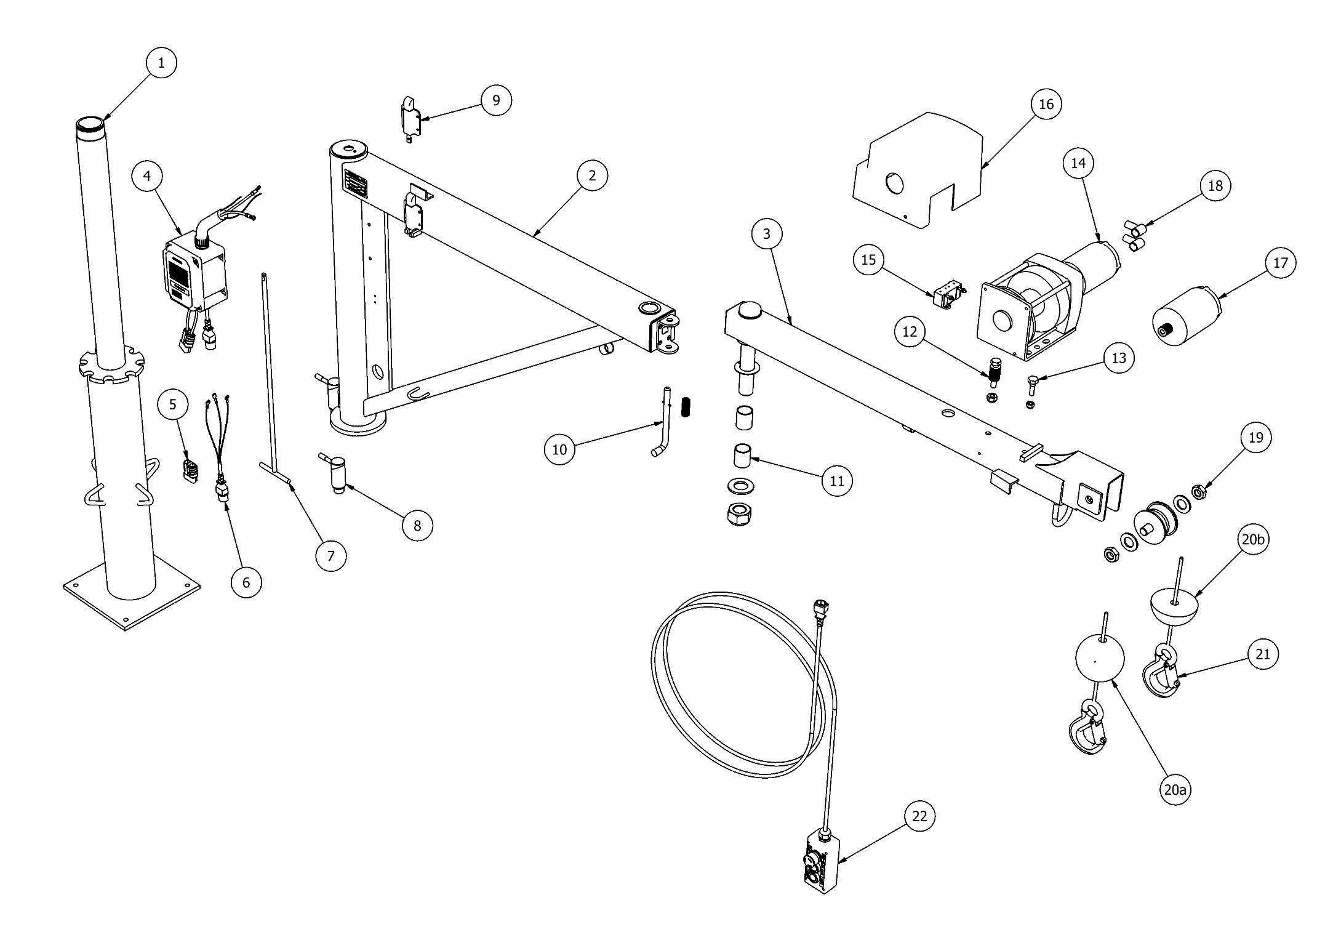

KJ250/2 RPT – Parts List

ITEM |  | PART NUMBER | DESCRIPTION | QTY
1 |  | 541-000011 | Pillar - Assembly | 1
2 |  | 056-000120 | Crane Body | 1
3 |  | 056-000123 | 2nd Boom | 1
4 | A | 195-000010 | Solenoid Box & Wiring Harness - 12V | 1
 | B | 195-000011 | Solenoid Box & Wiring Harness - 24V | 1
5 |  | 108-000001 | Anderson Power Connector - 50A | 1
6 |  | 547-000033 | Remote Connector & Tail | 1
7 |  | 171-000019 | Catch Handle | 1
8 |  | 539-000045 | Cam Lock | 1
9 |  | 079-000023 | Slam Latch | 1
10 |  | 079-000025 | Shoot Bolt - Assembly | 1
11 |  | 035-000056 | Joint Bearing - Assembly | 1
12 |  | 713-200005 | Disc Spring - Assembly | 1
13 |  | 200-000009 | Shoulder Bolt - Assembly | 1
14 | A | 077-000024 | Winch Assembly - 12V - Left Hand (LH) | 1
 | B | 077-000023 | Winch Assembly - 12V - Right Hand (RH) | 1
 | C | 077-000026 | Winch Assembly - 24V - Left Hand (LH) | 1
 | D | 077-000025 | Winch Assembly - 24V - Right Hand (RH) | 1
15 |  | 692-000008 | Microswitch - Assembly | 1
16 | A | 123-000035 | Winch Cover - L/H | 1
 | B | 123-000036 | Winch Cover - R/H | 1
17 | A | 614-000005 | Winch Motor - 12V | 1
 | B | 614-000007 | Winch Motor - 24V | 1
18 |  | 042-000001 | Terminal Rubber Boot | 2
19 |  | 555-000017 | Pulley Wheel - Assembly | 1
20 | A | 022-000002 | Bob Weight - Assembly | 1
 | B | 022-000004 | Half Bob Weight - Assembly | 1
21 | A | 079-000008 | Rope 15' (4.5m) & Hook - Assembly | 1
 | B | 079-000009 | Rope 20' (6.0m) & Hook - Assembly | 1
 | C | 079-000010 | Rope 30' (9.1m) & Hook - Assembly | 1
22 |  | 560-000016 | Remote Control (3 Button Handset) | 1

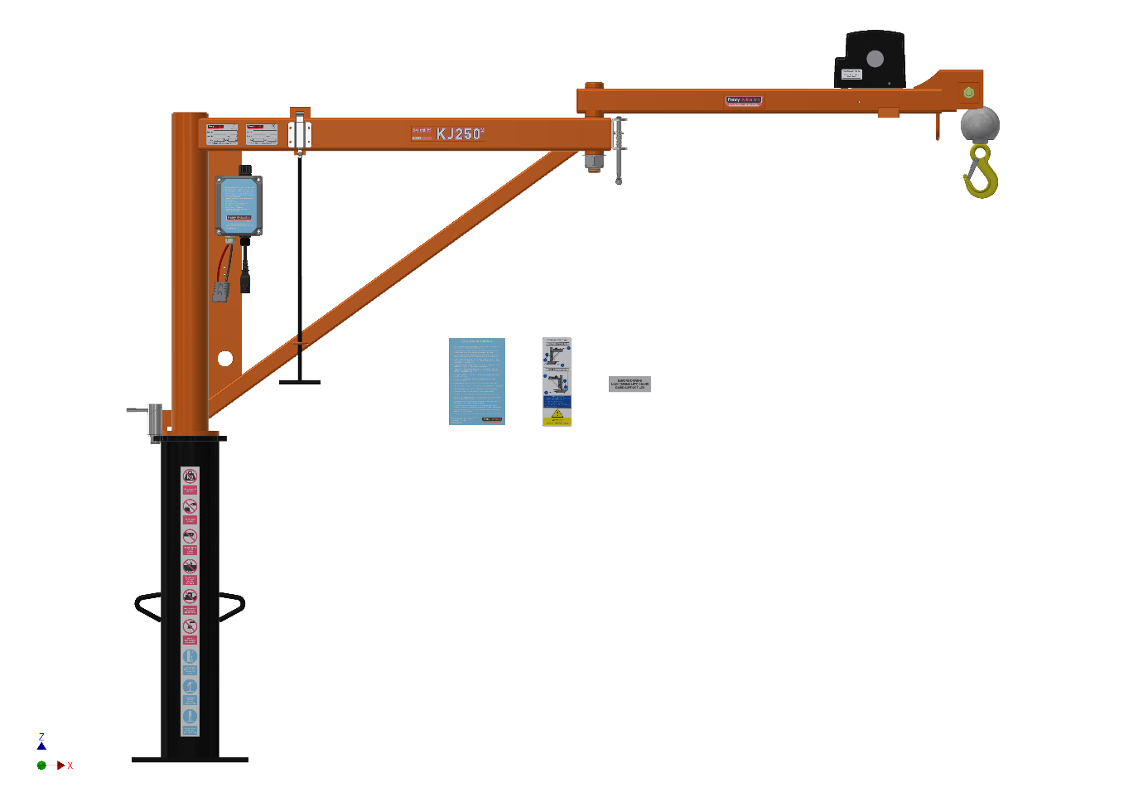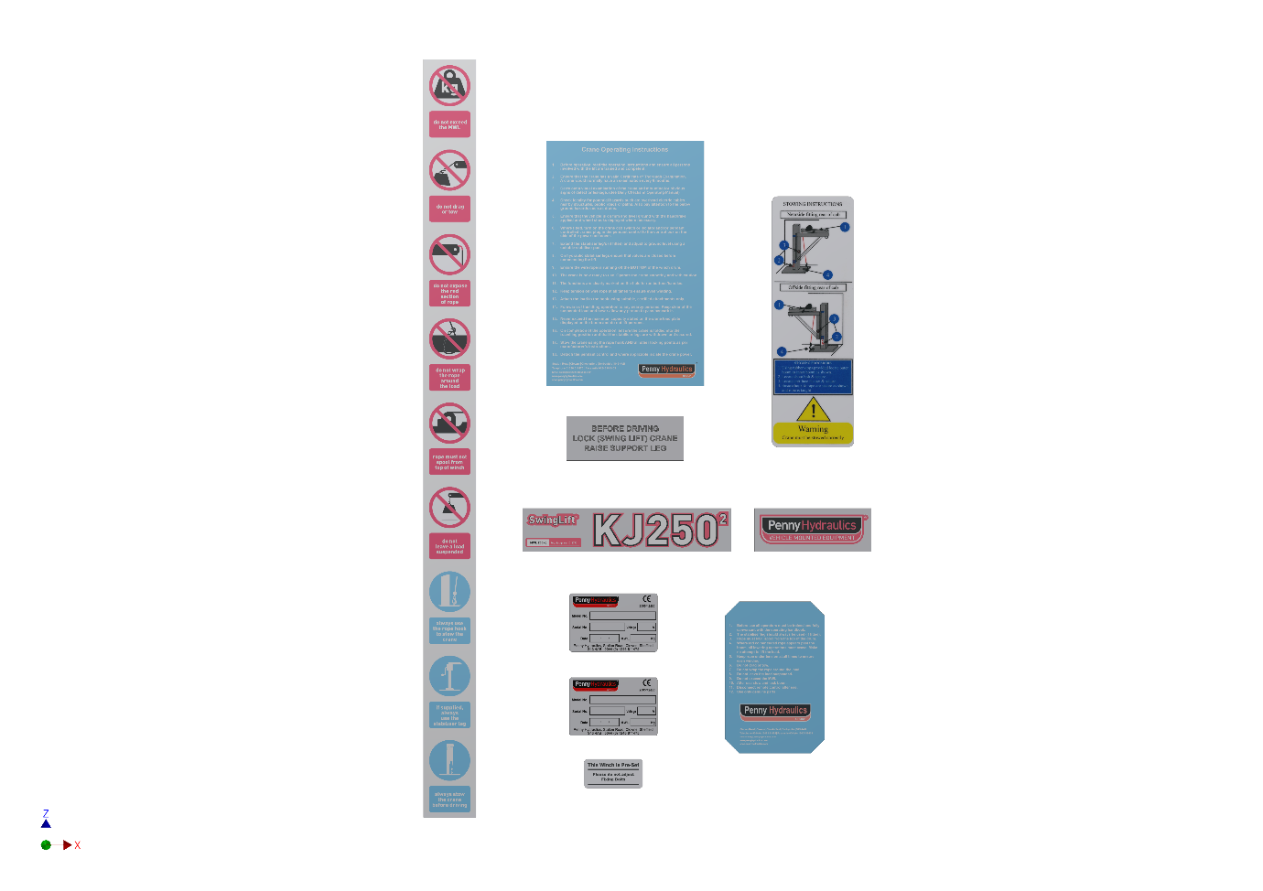

KJ250/2 GHT / RPT
Item | Part Number | Description | Qty
1 | 500-000193 | This winch is preset sticker | 1
2 | 500-000196 | KJ250/2 GHT Boom Label Set | 1
3 | 500-000022 | Manufacturers CE Plate | 1
4 | 500-000179 | Installers CE Plate* | 1
5 | 500-000184 | Operating Instructions | 1
6 | 500-000031 | Caution Sticker Blue | 1
7 | 500-000182 | Vertical Sticker (9 safety warning icons) | 1
8 | 500-000183 | Before driving sticker | 1
9 | 500-000185 | Stowing Instruction | 1

EC Declaration of Conformity

This declaration relates exclusively to the machinery in the state in which it was supplied, and excludes components, which are added, and/or operations carried out subsequently by the final user.

We Penny Hydraulics Limited, Station Road Industrial Estate, Station Road, Clowne, S43 4AB.

Hereby declare that the product(s) listed below: -

Model: | SwingLift Knuckle Joint Series
Serial No:

Conforms to the essential requirements of 2008 / 1597, The Supply of Machinery (Safety) Regulations 2008 and the following Directives, Standards and other Normative Documents where appropriate.

EU Directives and Regulations | Machinery Directive 2006/42/EC  Electrical Equipment (Safety) Regulations 1994  European Council EMC Directive 89/336/EEC
Standard(s) | BS 7121 Parts 1,2 and 4  BS EN 982 Safety of Machinery  EN 50081-1: 1997; Electromagnetic Compatibility, General Standard  Radiated RF Emissions Class B (30MHz – 300MHz)
Normative Documents | DIN 15018 Steel Structures  BS 2573 Rules for design  The Lifting Operations and Lifting Equipment Regulations 1998.  The Provision and Use of Work Equipment Regulations 1998.
All information is given within a Technical File compiled by: Mr Terry Brocklehurst c/o Penny Hydraulics Ltd.

Place: Penny Hydraulics Limited | Signature: | 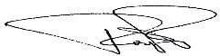
Date: | Full Name: | TJ Penny
 | Position: | Managing Director

BS EN ISO 9001: 2015 British Standards Institute Registered Company
Certificate No. FM 20203

Training Register

Health and safety legislation requires that all employers ensure all people using or supervising the use of work equipment have received adequate training in the method, risk and precautions.
Penny Hydraulics offers nationwide training by qualified instructors for the full range of lifting equipment. Training includes practical and theoretical input from the delegates with a certificate of competence issued on successful completion of the course.

Date | Trained operator | Signature | Trained by | Signature

Work Record

Date | Work done/remarks | Engineer | Company

Penny Hydraulics Limited Warranty Policy

This Policy is intended to provide our customers with the best possible support to ensure trouble-free use of their new Penny Hydraulics lifting equipment.

Products sold by the Company are guaranteed to be free from defective material and workmanship for a period of one year from the date of invoice or from the date of the commissioning certificate.

This warranty applies only under the following conditions:

- The unit or part must not have been subject to neglect or abuse or operated under abnormal conditions or in an unapproved application.
- The responsibility of the Company is restricted to what is, in their judgement an adequate repair or replacement of the Company’s product.
- An authorised engineer must carry out a six-monthly inspection.
- The warranty is void if examination reveals that the unit or part has been repaired or adjusted other than by an authorised engineer.
- Normal service repairs carried out by authorised engineers are supported by their own warranty.
- Warranty does not extend to consumable items requiring replacement due to normal wear and tear.

Any claim under warranty must be made in the first instance by contacting Penny Hydraulics Ltd Service Department on 01246 811475 or via email at sales@pennyhydraulics.com. The decision will then be made on how best to proceed after consultation with the customer.

UK Mainland
We will normally have one of our own engineers based around the country visit the site to rectify the problem. This policy may be varied at our discretion, but it is our aim to give the very best possible response to minimize product downtime and inconvenience.

Other Locations
Warranty is limited to a parts only service but in certain areas, we have service partners who may be able to assist. Any defective item should be returned to Penny Hydraulics Ltd for inspection and any valid warranty claim will include reasonable carriage costs both ways. A replacement part will then be sent to the customer.

No variation of the warranty as stated in the Company’s Standard Terms and Conditions of Sale is authorised unless agreed in writing by a Director of the Company. This is the only warranty given and the Company accepts no other responsibility.

